1.
INCLUDE Irvine32.inc

.data
msg1 BYTE "Password is strong.",0
msg2 BYTE "Password must include at least 1 digit.",0

password BYTE 32 DUP(?)
compare BYTE '0','1','2','3','4','5','6','7','8','9',0

.code
main PROC

mov edx, OFFSET password
mov ecx, 31
call ReadString

mov esi, OFFSET password
mov ebx, 0

check_password:
lodsb
cmp al, 0
je doneScanning

mov edi, OFFSET compare
mov ecx, LENGTHOF compare

cld
repne scasb

jne check_password

mov ebx, 1
jmp doneScanning

doneScanning:
cmp ebx, 1
je strong

weak:
mov edx, OFFSET msg2
call WriteString
jmp quit

strong:
mov edx, OFFSET msg1
call WriteString

quit:
exit
main ENDP

END main
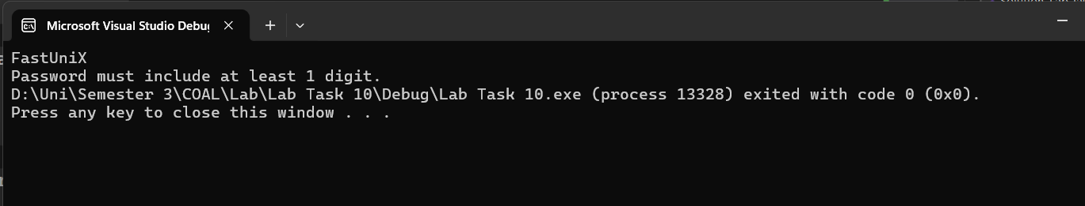
2.
INCLUDE Irvine32.inc

.data
inp BYTE 32 DUP(?)
nospace BYTE 32 DUP(?)

.code
main PROC

mov edx, OFFSET inp
mov ecx, 31
call ReadString

mov esi, OFFSET inp
mov edi, OFFSET nospace

nextChar:
lodsb
cmp al, 0
je done

cmp al, ' '
je nextChar

mov [edi], al
inc edi
jmp nextChar

done:
mov byte ptr [edi], 0

mov edx, OFFSET nospace
call WriteString

exit
main ENDP

END main
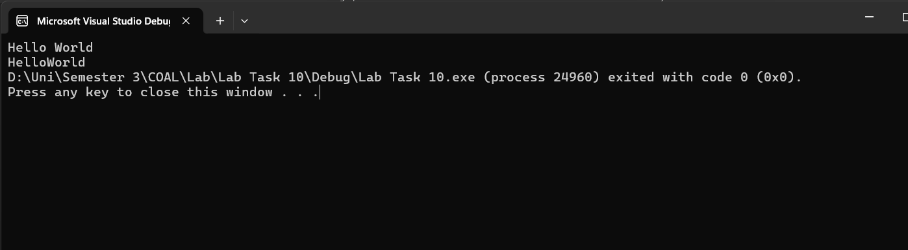
3.
INCLUDE Irvine32.inc

.data
prompt BYTE "Enter a string: ",0
inputStr BYTE 80 DUP(?)
wordCnt DWORD ?

.code
main PROC

mov edx, OFFSET prompt
call WriteString

mov edx, OFFSET inputStr
mov ecx, 79
call ReadString

mov esi, OFFSET inputStr
mov eax, 0
mov bl, ' '
mov dl, 1

countLoop:
lodsb
cmp al, 0
je doneCount

cmp al, ' '
je isSpace

cmp dl, 1
jne notNewWord
inc eax

notNewWord:
mov dl, 0
jmp countLoop

isSpace:
mov dl, 1
jmp countLoop

doneCount:
mov wordCnt, eax
mov eax, wordCnt
call WriteDec

exit
main ENDP

END main
